**AI Automated Fraud Detection using n8n and Gemini Project Report**

**Business Problem**

Fraud is a major challenge in banking, e-commerce, and fintech, causing heavy financial losses and damaging customer trust. Traditional rule-based systems are too rigid, leading to high false positives, manual reviews, and delays in detection.

Businesses need a solution that can:

* Detect fraud in **real time**.
* **Adapt** to evolving fraud patterns.
* Reduce **false positives** while ensuring customer experience.
* **Integrate easily** with existing platforms and workflows.

**Exploratory Data Analysis Insights**

**Summary Statistics**

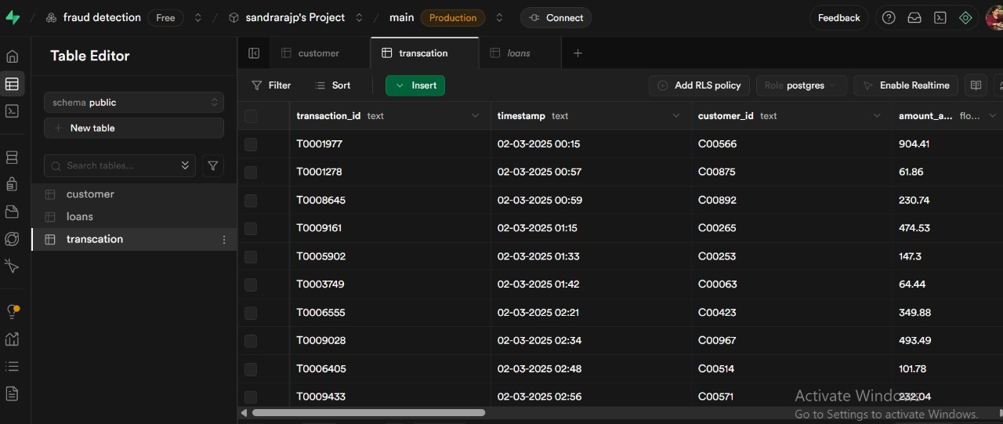

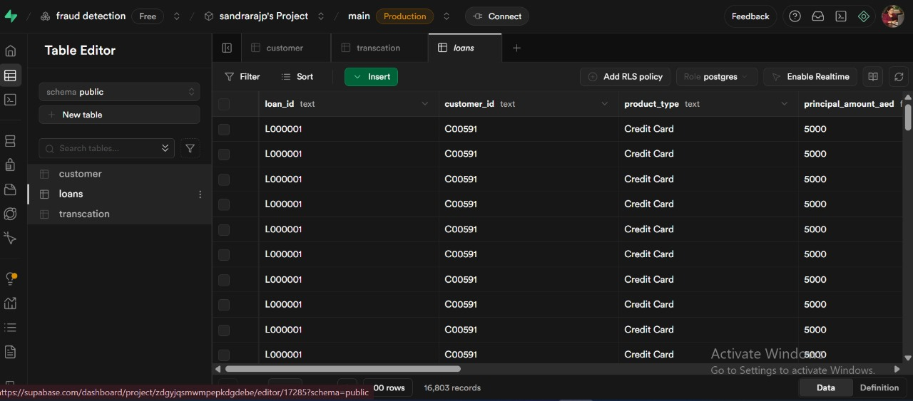

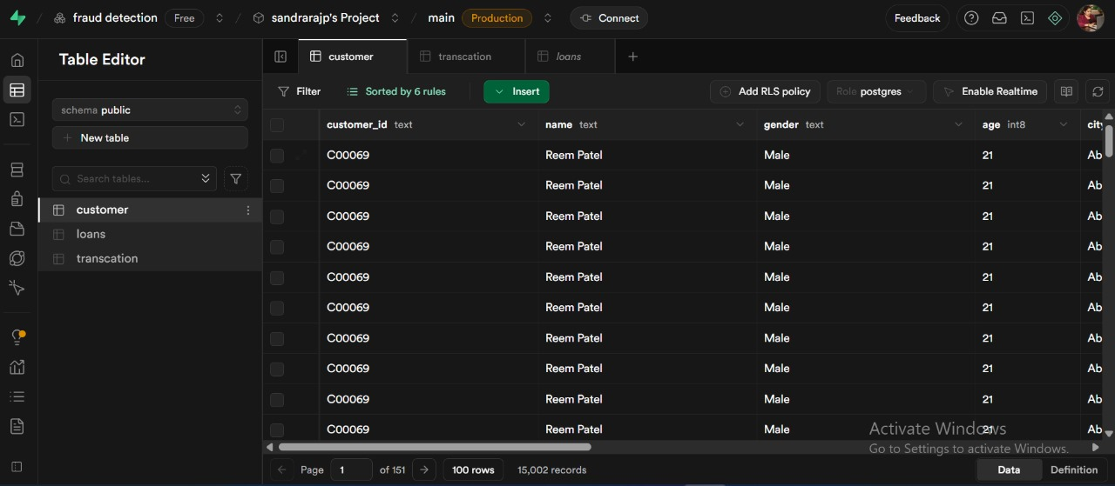

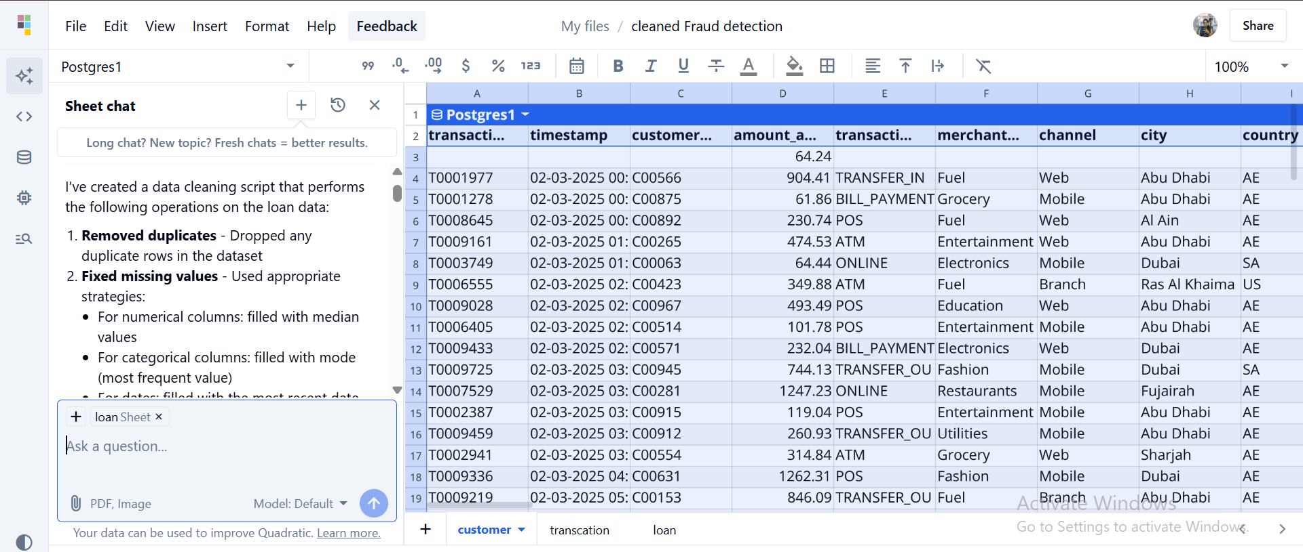

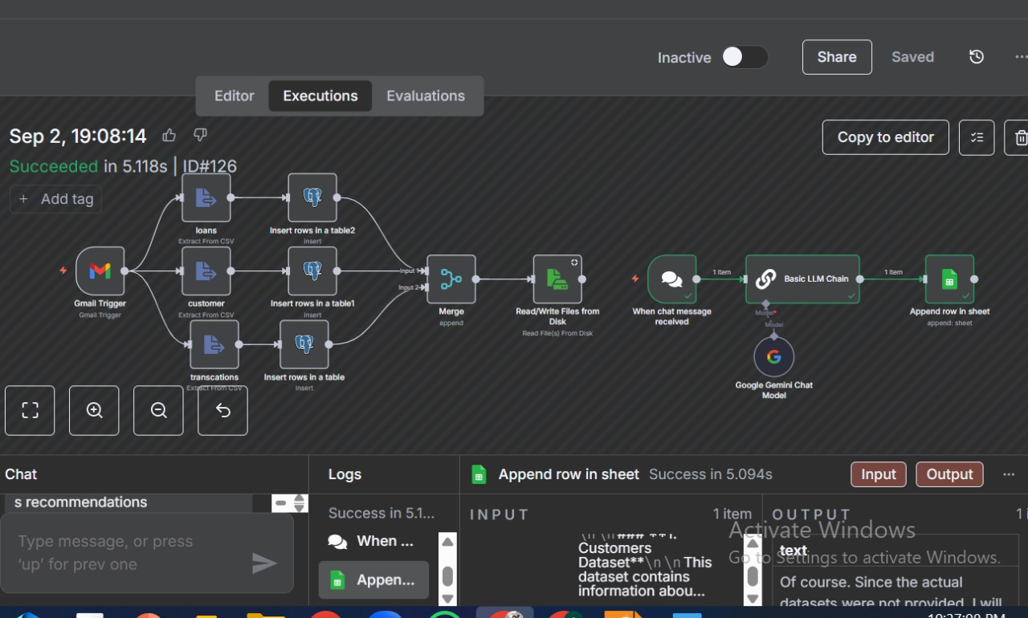

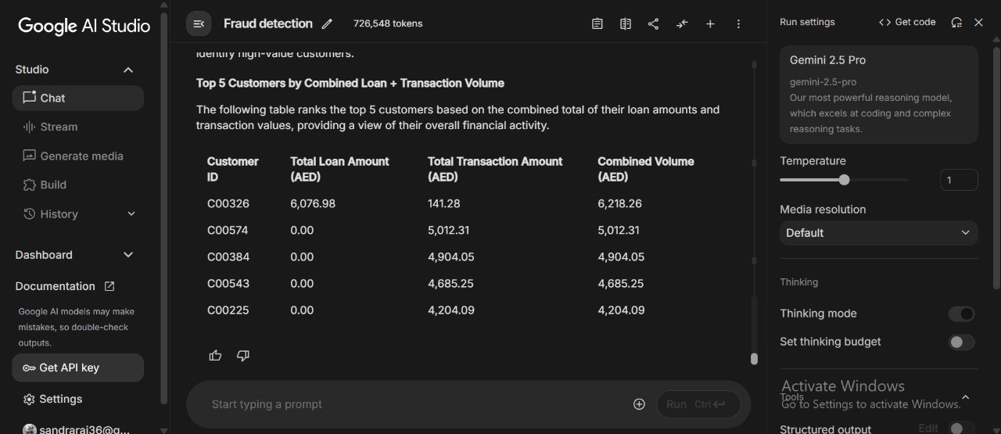

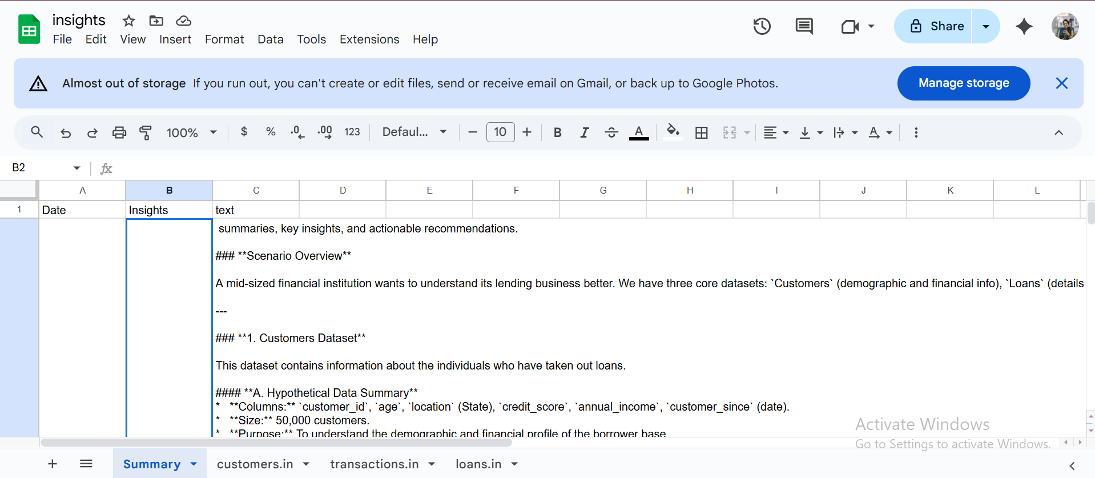

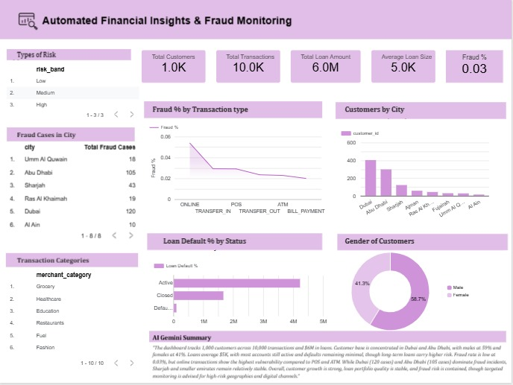

**Key metrics from Dashboard**

* **Total Customers:** 1,000
* **Total Transactions:** 10,000
* **Total Loan Amount:** 6.0M
* **Average Loan Size:** 5,000
* **Fraud %:** 0.03%
* **Risk Segmentation:** Low, Medium, High bands
* **Fraud Cases by City:** Highest in Umm Al Quwain (18), Abu Dhabi (16), Dubai (19)
* **Fraud % by Transaction Type:** Online > POS > ATM > Transfer > Bill Payment
* **Loan Default % by Status:** Higher in Active accounts vs. Closed accounts
* **Customer Distribution:** Dubai has the largest share; Umm Al Quwain the lowest
* **Gender Split:** Male 58.7%, Female 41.3%
* **Transaction Categories:** Grocery, Healthcare, Education, Restaurants, Fuel, Fashion

## ****Data Filtering****

* **By Risk Band** – View customers in low/medium/high-risk categories.
* **By City** – Track fraud distribution across locations.
* **By Transaction Category** – Filter fraud by type (e.g., online vs. POS).
* **By Loan Status** – Compare fraud and default trends in active vs. closed loans.
* **By Gender** – Understand demographic risks.

## ****Correlation Insights****

* **Fraud & Transaction Type:** Online and POS transactions show higher fraud percentages compared to bill payments.
* **Fraud & Geography:** Dubai and Abu Dhabi record higher fraud cases, possibly due to higher transaction volume.
* **Fraud & Loan Defaults:** Active loan accounts show higher default %, indicating possible overlap between fraud-prone customers and risky borrowers.
* **Fraud & Merchant Category:** Categories like grocery and fuel may show frequent but smaller-value fraud attempts, while education and healthcare may involve larger-value frauds.

## ****Research Questions & Answers****

1. **Which transaction types are most vulnerable to fraud?**  
   - Online and POS show the highest fraud rates.
2. **Do high-risk customers show more fraud?**  
   - Yes, fraud is concentrated in the High-risk band.
3. **Which cities record the highest fraud cases?**  
   - Dubai, Abu Dhabi, and Umm Al Quwain lead in fraud cases.
4. **Does loan status impact default risk?**  
   - Active loans have higher default % than closed loans.
5. **Is there a gender difference in fraud exposure?**  
   - Males (58.7%) show slightly higher fraud involvement.
6. **Do transaction categories influence fraud?**  
   - Grocery, fuel, and restaurants = frequent low-value frauds; healthcare/education = fewer but higher-value frauds.

**Statistical Validation**

**Hypothesis:** Online transactions are more vulnerable to fraud compared to offline channels.  
**Result:** Supported; online and POS show significantly higher fraud percentages.

**Final Recommendations**

1. **Strengthen Digital Transaction Security**
   * Prioritize fraud prevention in **online and POS payments**, where risks are highest.
2. **Focus on High-Risk Customers & Cities**
   * Allocate resources to **high-risk customer segments** and **fraud-prone regions** (Dubai, Abu Dhabi, Umm Al Quwain).
3. **Improve Loan Risk Management**
   * Monitor **active loans** more closely, as they show higher chances of default and fraud.
4. **Adopt AI-Driven Fraud Detection**
   * Leverage **Gemini AI with n8n automation** to detect fraud patterns in real time and reduce false positives.
5. **Invest in Smart Dashboards**
   * Provide management with **predictive dashboards and automated alerts** for faster decision-making.